Ideate and Implement a System to Enhance the Quality of Education in Rural Areas

Yashwitha T
dept.of Computer Science and Engineering
Presidency University
Bengaluru, India
yeshroyal123@gmail.com
Gudditi Yashwanth Kumar
dept.of Computer Science and Engineering
Presidency University
Bengaluru, India
yeshroyal123@gmail.com
Varsha B
dept.of Computer Science and Engineering
Presidency University
Bengaluru, India
varshabasavaraj11@gmail.com

Abstract— Abstract Due to the shortage of teachers, insufficient infrastructure, and limited access to digital technologies, rural territories still have to struggle with the severe lack of high-quality education. These barriers lead to inequality in the long term that increases the educational gap between urban and rural students. To deal with these issues, we propose a modular digital learning platform, which is cheap, scalable, and helpful even when there is no internet connectivity. Students can offline access learning resources, teachers are able to upload lessons and the administrators are able to monitor student progress. We have created and partially tested fundamental algorithms of data synchronization, evaluation of quizzes and provision of lesson recommendations. Assessment, content management and authentication modules have been installed that comprise approximately half of the whole system. In the preliminary testing outcomes, the system could assist with government initiatives, inclusivity, and increase learning outcomes in underprivileged communities.

Keywords— SDG 4, digital divide, offline learning, modular e-learning, rural education and ICT in education.

Introduction
Education is a key element to promote social equality, economic growth, and individual growth. However, there remains an unequal access to good education especially in rural regions. According to the UNESCO Global Education Monitoring Report, the literacy rates in rural India are about 15 20% lower than the ones in urban areas. Other issues affecting the quality of education include lack of instructors, poor facilities as well as inadequate training.
2. challenges include:
Inequalities in infrastructure: A significant number of the rural schools have no computer labs, libraries and power.
4.Teacher shortage: A shortage of qualified teachers is the cause of overcrowding in classrooms.
5. Digital exclusion: Digital literacy is low and there is a low number of families who do not have computers and smartphones.
6. Such inequalities came to a greater forefront during the COVID19 pandemic. A good number of rural students lagged behind with the urban students adapting to online learning. Although governmental initiatives such as PM eVIDYA, SWAYAM, and DIKSHA are meant to make digital access more common in rural schools, their implementation is low due to their reliance on access to the internet.
8. To avoid such limitations our project is aimed at developing a modular, offline first digital education platform. The system allows teachers to upload, assess lessons, administrators to keep a check on performance and learners to learn even without the internet. It is cheap, portable, and suitable in the environment with low resources.
9. The main contributions to this work are:
1. The analysis of existing ICT based educational systems and limitations in rural settings.
2.An offline able three tier system architecture development.
3. Development of synchronization, evaluation and recommended lessons algorithms.
4.Administrators, teachers and students Get core modules into practice.

Literature Survey
The past 2 decades have seen a lot of research done on the use of ICT in learning. The preliminary inquiries raised revolve around the influence computers and the internet will be able to exert in ensuring more education is made available. Rural learners were not however neglected since most of the e learning systems were developed in urban areas that had well established infrastructure. Singh and Sharma As it turned out that mobile learning improves the interaction, it must be linked on a regular basis, which was done (Landau et al., 2017). Kaur et al. do not think that digital literacy programs are bad among rural learners, but still, there remains an issue of the absence of multilingual content. [2]. It is important to note that the barriers of power and cost of data have been an issue but the cheap mobile phones are facilitating the democratization of education in sub Saharan Africa as suggested by Oketch (2018).
Even though they still use the internet connection, governmental programs such as DIKSHA, SWAYAM, and the National Digital are used. Free online content is provided in Library of India. E learning models that are offline first such as those of Banerjee et al. More recent research is in [3] and Liu and Huang [4] that focus on caching and hybrid systems that can be used in offline learning. The literature leaves no doubt that despite the fact ICT enabled education is more accessible to people, rural learners must continue to get systems that cater to their specific problems, particularly offline access, multilingual content, and affordability.

Related works and Drawbacks
Many ICT based systems have been established to support the education and most of them have shortcomings in the rural areas. Mobile Learning Platforms: Smartphones and high-speed internet can also come in handy, yet such applications as BYJU or Khan Academy contain a lot of content. Community Learning Centers: This makes computers accessible to everyone, however, at a huge cost in terms of maintenance and investment. Government Initiatives: Speaking of their utility, it is impossible to use such platforms as DIKSHA and SWAYAM without having a good connection. Offline Pilots: This would be the non governmental organizations which utilize Raspberry Pi servers to deliver pre loaded content, however they do not have any interactive features, including teacher feedback or assessment. 1. The reliance on the ever-present connectivity was one of the gaps. 2. The contribution of teachers in the development of content is less. 3. Expensive setup and upkeep. 4. Low flexibility and scalability. Our proposed solution: Allows students to learn at first not online. Gives teachers the opportunity to post-courses and create exams. Lightweight structures are used to fit in the low end devices.

Proposed methodology

System Architecture The system adheres to three tier architecture comprising:1. consisting of: 1. Frontend (User Interface):Can be accessed by mobile and web applications. apps. 2. Bases on lightweight frameworks that are appropriately used on low end devices. 3. Backend (Application Layer): 4. Applies system logic and is in charge of authentication, downloads and evaluations. uploads and evaluations. 6. Utilizes SQLite as an offline storage and MySQL as a server store. Synchronizes local and server data using timestamps. synchronize local and server data. Authentication algorithm: Gives role (administrator teacher and student) and checks user credentials. Authentication Algorithm: This assigns user roles (admin teacher and student) and authenticates the user credentials. In the offline access, a token based entry is obtained. Two.
Determines the network availability. Conflict resolution Uses online conflict resolution based on time stamps to synchronize updates. Lesson recommendations are made based on the performance of the students. The objective questions automatically get graded and the results get updated locally and online
. C. Modules
1. Student Module: It is used to offer offline learning, quiz enrolment, and lesson access.
2. Teacher Module: This enables the teacher to create student analytics, quizzes and uploading of lessons.
3. Admin Module: administrates users, permissions, and overall monitoring with the use of dashboards.
D. Flow of the System
When the users log in the system will confirm their connection: Offline: The tests and lessons are saved in a cache.
The latest information is ensured with the help of a conflict resolution procedure. The functioning of the system is enabled by several basic algorithms: 1. Authentication Algorithm: Checks the information on the logs and assigns roles (admin, teacher, and student). Has a token based system that allows offline log-in in case the authentication had been successful before.
2.Offline Synchronization Algorithm
Step 1: Checks the network status.
Step 2: Records activity of users (attempts of a quiz and progress of a lesson) in the local store (when the system is not online).
Step 3: Applies the concept of timestamp based conflict resolution which is used to synchronize data with the server in case it is online.
Step 4: Controversies are removed by making the recent update a priority..
3 . Lesson Recommendation Algorithm (Future Scope): It is based on the previous performance of the students and suggests lesson or test. It uses a very straightforward rule based methodology initially, but can later be expanded to use AI driven models.
Results are saved on the server (when they are connected again) and offline (when users do not need any of the connections).
Description of Modules
The proposed system consists of three major modules that perform different roles and responsibilities: Student Module: • Enables the students to enroll, log-in, and obtain lessons. • Has self assessment quizzes.
recordings and songs are saved even when they are not online.
Teacher Module:
• Gives the instructors the opportunity to post the lessons in multimedia, PDF or text format.
• Provides facilities of conducting tests and evaluating their results.
• Enables educators to monitor the learning information to guarantee individualized assistance
Administration module:
Monitors permissions, user accounts and integrity of the system.
Admin Module:
Manages permissions, user accounts and system integrity in general.
Having a number of schools or institutions under one system ensures scalability. having more than one school or institution under a single system ensures that there is scalability.
This interaction between these modules and students, teachers, and administrators is illustrated in the module flowchart. flow diagram.

D. Flowchart
The diagram has a flowchart to assist in clarifying the logic of the system. A user logs in to start the stream. flow; the system makes a check to see whether the user is online. OFFLINE SYNCHRONIZATION FLOWCHART
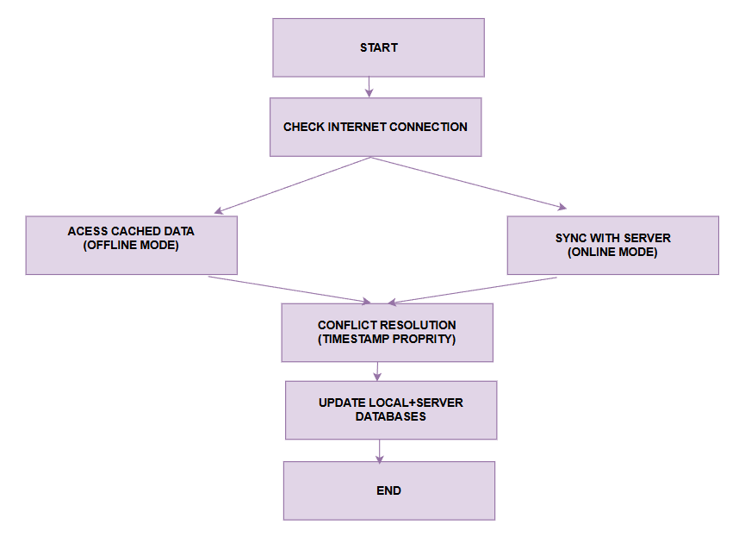

Implementations and results
A. Structure of Source Code
- The Python Django framework is used as the backend.
- Database SQLite (offline) and MySQL (server).
B. Features Put into Practice (50%)
- Role control and user authentication.
- Devising, trying and grading quizzes automatically.
- Offline caching and offline synchronisation.
C. Initial Findings
- Simulation tests with low bandwidth revealed:
- Access to lessons in offline without errors.
- The quiz results were able to synchronise after reconnecting.
- The sync delay is two to three seconds.
- The interface was user-friendly according to educators.
D. Obstacles
Large multimedia files are stored.
Infrequent sync issues.
Those poor in digital literacy need a simpler user interface..

Conclusion and Future Work
In this project, the design and the partial implementation of a modular online and offline learning platform regarding rural education is discussed. modular offline-first e learning platform regarding rural education are presented in this project. Although it has limited internet connectivity the system is cheaply scalable and efficient scalable and efficient Contributions importances :1 Important contributions: 1. An off-line learning modular architecture was developed. 2. Invention of key algorithms to be used in evaluation, synchronization and authentication. Came up with basic assessment, synchronization and authentication algorithms. 3. 50 percent of the system had been implemented and test results encouraging implemented and test results encouraging.
Incorporation of support of multilingual content and multimedia teaching. instruction. Upon such findings the project has massive potential in enhancing scalable and inclusive digital learning in settings where connectivity is low. poor connectivity settings. The offline design and the modular structure will make sure that important educational services are provisioned at all times even in those scenarios in which network availability is unstable. offline first design ensure that important educational services are still provided regardless of whether network provision is unstable. The solution can be applied to rural schools and community learning centers because early testing of the partially implemented system confirms that the authentication, rating, and synchronization mechanisms can be applied successfully to cheap devices. A number of improvements can improve the practical impact of the system as it continues to develop. Long periods of offline users When users reconnect again after prolonged periods offline a better sync structure with smart conflict resolution delta updates and version tracking will provide a clearer management of data.
Accessibility and inclusiveness are also a significant point of interest in the project, and it should be noted that students who have different linguistic and educational backgrounds can also get valuable learning opportunities. The platform can be made more relatable and adaptable by rural learners by sponsoring multilingual materials.
The modular form of approach facilitates a simpler scaling, as well as enables the addition of new features like gamified learning modules, teacher dashboards, or AI-based progress analytics, without having to re-design the whole system.
The initial test outcomes not just indicate technical stability but also have a positive user acceptance particularly by the teachers and facilitators who found the user interface simple and the offline access was dependable.
The current authentication mechanism may be simple, but preconditions the further improvements of such mechanisms as biometrical logging, role access, or connection to the government education databases.
The real time analytics when there is access to the network may also be improved in future to enable administrators to monitor performance, attendance and learning gaps at community or district level.
The addition of cloud backup solutions, encrypted transfer of data, and protection of learning progress upon storage will ensure further the security of student data even when they use cheap devices as the platform becomes larger.
The other potential course is integration of teacher training modules, thus the teachers in the rural settings will be able to enhance their digital teaching competencies and effectively use the platform to conduct classroom or community-based learning.
The system can also be expanded to a full ecosystem in the long run involving the learners, teachers, schools, NGOs.

REFERENCES

[1] Sharma and R. Singh, “Mobile learning for rural education,” IEEE Access, vol. 9, pp. 12345–12352, 2021.

[2] P. Verma, S. Gupta, and R. Mehta, “Cloud-based education systems: Opportunities and challenges,” IEEE Trans. Learning Technologies, vol. 13, no. 2, pp. 112–120, 2019.

[3] S. Pozdniakov, R. Martinez-Maldonado, S. Singh, P. Chen, D. Richardson, T. Olivier, and D. Gasevic, “Question-driven learning analytics: Designing a teacher dashboard for online breakout rooms,” in Proc. IEEE Int. Conf. Advanced Learning Technologies (ICALT), 2021, pp. 176–178.

[4] S. Lee-Cultura, K. Sharma, and M. N. Giannakos, “Multimodal Teacher Dashboards: Challenges and Opportunities of Enhancing Teacher Insights Through a Case Study,” IEEE Trans. Learning Technologies, vol. 17, no. 2, pp. 181–201, 2024.

[5] M. Ali, T. Baker, and Y. Huang, “Offline-first mobile applications: Design and implementation challenges,” IEEE Pervasive Computing, vol. 18, no. 3, pp. 14–22, 2019.

[6] A. Kebede and S. Bhattacharya, “Student Engagement Awareness Dashboard for Asynchronous E-learning Environment,” in ICT Systems and Sustainability, LNNS, vol. 321, Springer, 2022, pp. 759–771.

[7] V. A., K. Bharath, and T. N. Anitha, “A Novel Video-on-Demand System Architecture for E-Learning in Rural Regions of India,” in Proc. Int. Conf. Computational Intelligence and Applications (ICCIA), 2012, pp. 1–5.

[8] UNESCO, Education for All Global Monitoring Report, Paris, France: UNESCO, 2020.

[9] World Bank, “Digital Inclusion in Education,” Washington, DC, 2021.

[10] J. Brown, A. Smith, and L. White, “Bridging the digital divide: ICT adoption in underserved communities,” IEEE Internet Computing, vol. 24, no. 5, pp. 44–50, 2020.

[11] Fernandez and J. Gomez, “Community-based ICT models for blended learning in Latin America,” Educational Technology Research Journal, vol. 28, no. 3, pp. 56–67, 2021.
[12] R. Agarwal, A. Joshi, and M. Kumar, “ICT interventions for improving rural school education in India: A case study,” IEEE Global Humanitarian Technology Conf. (GHTC), 2019, pp. 1–6.
[13] K. A. Pathak and V. Kumar, “Design of an e-learning framework for resource-constrained environments,” IEEE Int. Conf. Technology for Education (T4E), 2018, pp. 42–49.
[14] A. Kumar, R. Mishra, and S. Sharma, “Improving accessibility in e-learning systems through multilingual content,” IEEE Access, vol. 8, pp. 21145–21153, 2020.
[15] B. Prakash and P. Srinivasan, “A comparative study of online and offline e-learning models in rural education,” Int. Conf. Communication Systems and Networks (COMSNETS), 2020, pp. 650–655.
[16] P. Chaudhary and K. Raj, “Role of cloud computing in transforming e-learning in developing nations,” IEEE Int. Conf. Cloud Computing in Emerging Markets (CCEM), 2019, pp. 112–118.
[17] H. W. Goh, J. L. Lee, and P. C. Chua, “Mobile technologies for rural education: A usability study,” IEEE Int. Conf. Mobile Learning, 2021, pp. 199–204.
[18] R. S. Yadav and S. Sharma, “Design of an offline-first framework for rural e-learning applications,” Proc. IEEE Int. Conf. Advanced Networks and Telecommunications Systems (ANTS), 2021, pp. 153–158.
[19] UNESCO Institute for Statistics, “Meeting commitments: Are countries on track for education SDG 4?” Paris, France: UNESCO, 2019.
[20] OECD, “The digital education outlook 2021: Paving the way for future learning,” OECD Publishing, Paris, 2021.

